IT23234598_ Perera O.N.K

IT2120 - Probability and Statistics

Lab Sheet 05

1)

2)

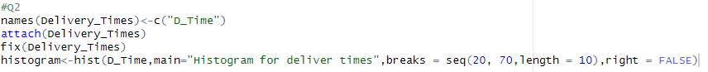

3)



4)



